Ls :- list
Ls -l :- for long list
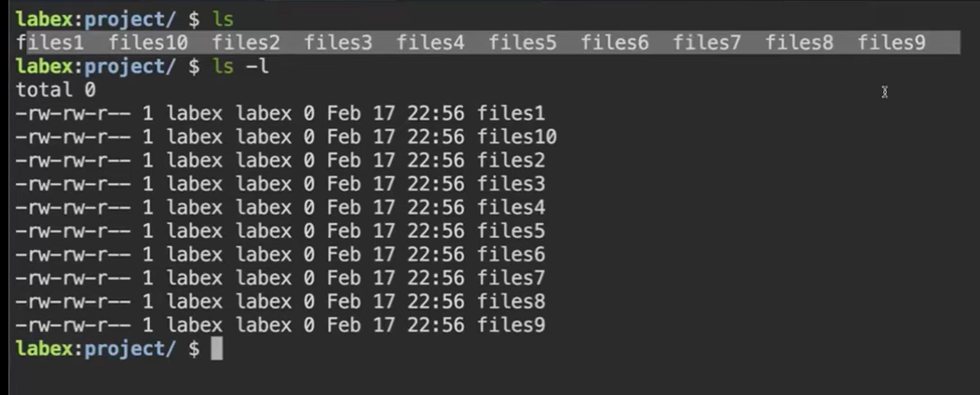
What if I want to check another directory what files or directory have
Ls -l /”directory name”
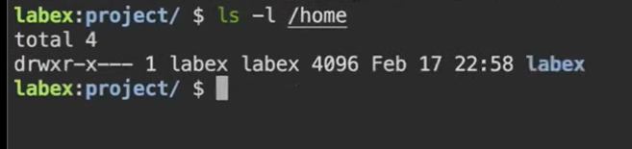

# Files and Directories
Q. What is mean by file?
Ans : A place were we can store our data
#We store our data in files and we store file in directory ( folder )
If I have different types of file like music file games file videos file etc if I upt all of them in same directory it will be confusing that’s why we store particular file to there places for eg: music file in music folder games files in game folder
--------------------------------------------------------------------------------------------------------------
# touch
Touch {file1,fil2,file3}
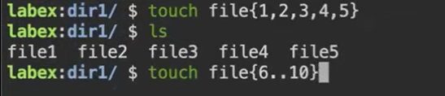
touch file{1..5}.txt ( it will give file1 to 5 in .txt )
--------------------------------------------------------------------------------------------------------------

#History
history command will help you to get your old commands that you recently used
--------------------------------------------------------------------------------------------------------------

#cd
Cd (change directory) cd <directory name> eg: cd Desktop
#Cd ..
Cd .. back to parent directory ( back to previous directory )

--------------------------------------------------------------------------------------------------------------

rm ( remove )
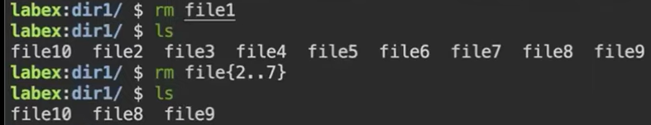
#rm *
To remove full directory files
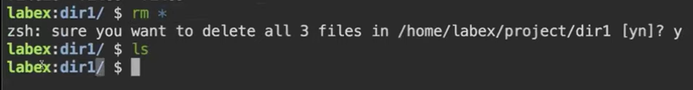
#rm -r dir2
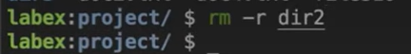
Remove directory but first remove inside files of that directory
But after removing file and typing ls command again and again is boring sometimes
That’s why we use -v (verbose) this means too print what I have remove
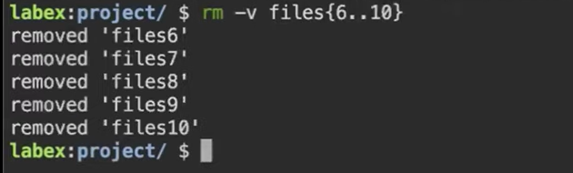
#rm -rvf ( -r recursive -v verbose -f forcefully ) -r recursive means go inside directory remove files, then -v verbose means show me what we removed, f means forcefully do it )
2 ways to perform this
#1

#2
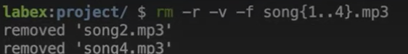

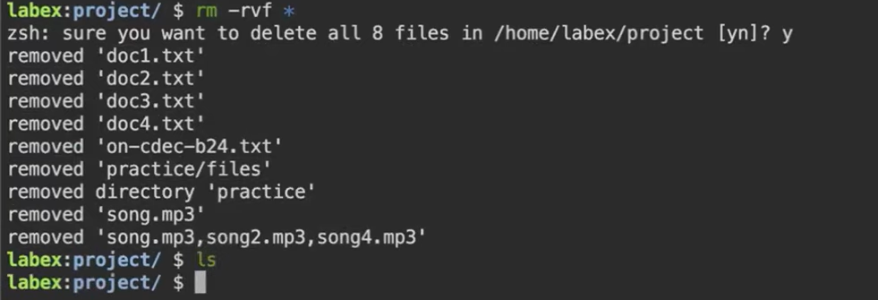
One of the most dangerous command
This command will delete everything that you have in your system files folder and once files are deleted they cant be restored like windows recyclebin
#cat (concatenate)
cat is used for print but you can store data using cat command how?
[ cat > hello
hii my name is ujer
how are you b6 students ]
After this press ctrl + D 
Example:
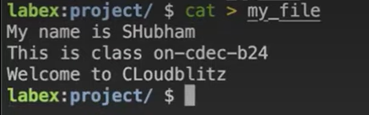
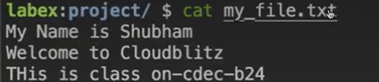
#cp
Copy same as mv
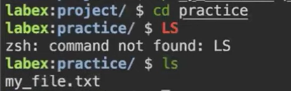
How to rename a directory
mv <olddirname> <newdirname>
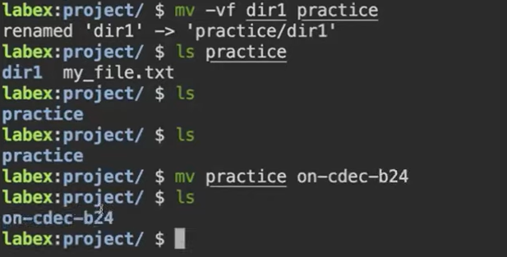
How to copy one folder only file into exsiting folder ?
Cp -r folder1/* newfolder
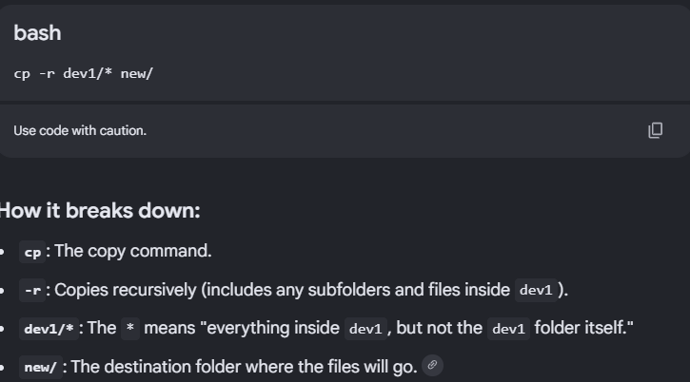
SUMMURY
